**EXPERIMENT - 10**

**AIM OF THE EXPERIMENT:**

Implement an IC555 Timer as astable multivibrator

**APPARATUS REQUIRED:**

PC loaded with multisim software

**THEORY:**

One popular application of the 555 timer IC is as an astable multivibrator or clock Circuit. Figure 3 shows an astable circuit built using 2 external resistors and a capacitor to set the timing interval of the output signal. Capacitor C charges toward VCC through external resistors RA and RB.

Referring to figure, the capacitor voltage rises until it goes above $\frac{2}{3}$ VCC . This voltage is the threshold voltage at pin 6, which drives comparator 1 to trigger the flipflop(𝑄 low 𝑄 high) so that the output at pin 3 goes low. In addition, the discharge transistor is driven on, causing the output at pin 7 to discharge the capacitor through resistor RB. The capacitor voltage then decreases until it drops below the trigger level $\frac{1}{3}$ VCC . The flipflop is triggered so that the output goes back high and the discharge transistor is turned off, so that the capacitor can again charge through resistors RA and RB towards VCC.

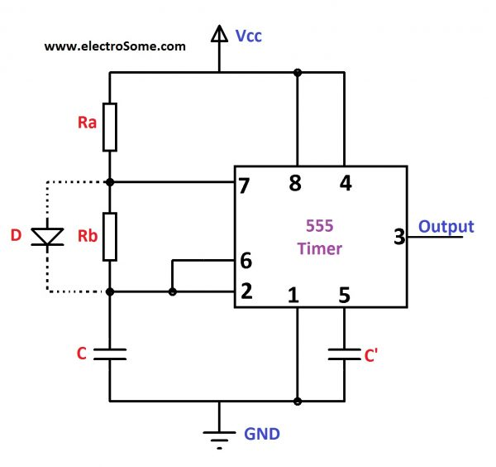

**Implementation:**

Circuit Diagram

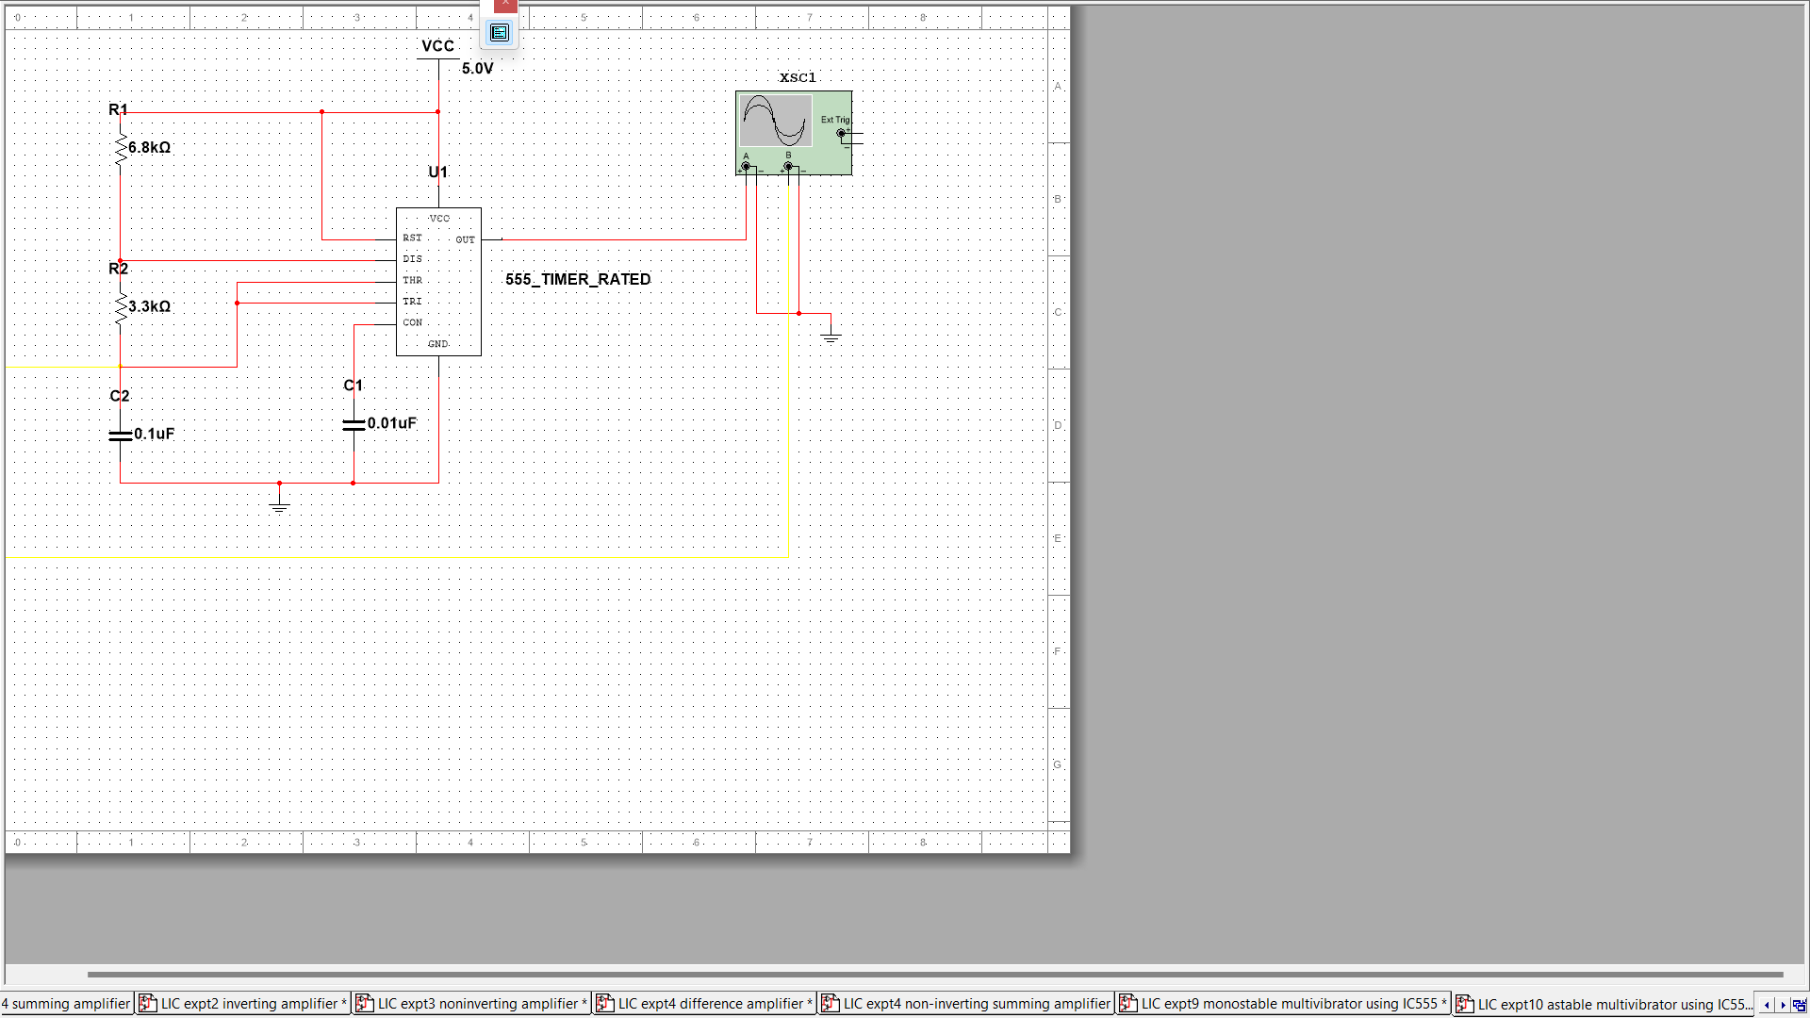

Waveform 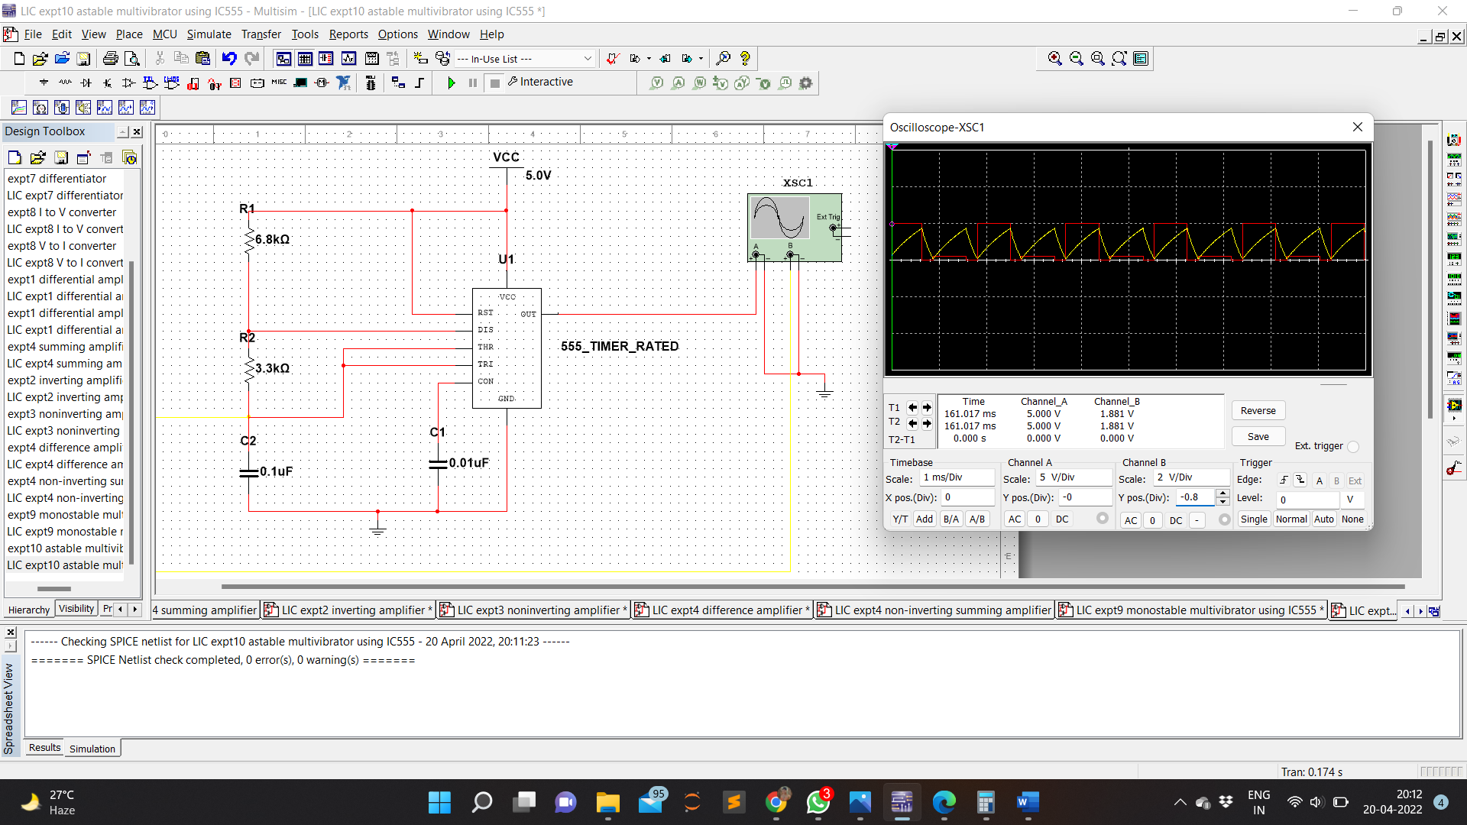

**RESULT:**

Astable multivibrator was implemented with the help of IC555 Timer using multisim and simulated.